Business Problem

In recent years, City Hotel and Resort Hotel have seen high cancellation rates. Each hotel is now dealing with a number of issues as a result, including fewer revenues and less than ideal hotel room use. Consequently, lowering cancellation rates is both hotels' primary goal in order to increase their efficiency in generating revenue, and for us to offer thorough business advice to address this problem. The analysis of hotel booking cancellations as well as other factors that have no bearing on their business and yearly revenue generation are the main topics of this report.

Assumptions

1. No unusual occurrences between 2015 and 2017 will have a substantial impact on the data used.

2. The information is still current and can be used to analyse a hotel's possible plans in an efficient manner.

3. There are no unanticipated negatives to the hotel employing any advised technique.

4. The hotels are not currently using any of the suggested solutions.

5. The biggest factor affecting the effectiveness of earning income is booking cancellations.

6. Cancellations result in vacant rooms for the booked length of time.

7. Clients make hotel reservations the same year they make cancellations.

Research Question

1. What are the variables that affect hotel reservation cancellations?

2. How can we make hotel reservations cancellations better?

3. How will hotels be assisted in making pricing and promotional decisions

Hypothesis

1. More cancellations occur when prices are higher.

2. When there is a longer waiting list, customers tend to cancel more frequently.

3. The majority of clients are coming from offline travel agents to make their reservations.

Analysis and Findings

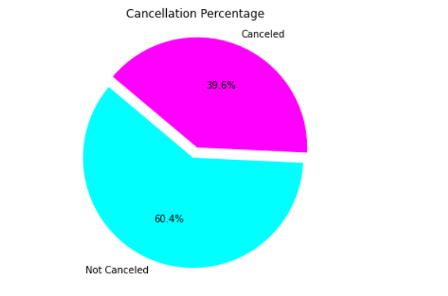

The bar graph shows the percentage of reservations that are cancelled and those that are not. It is obvious that there’s still significant number of reservations that are not cancelled.

It shows that 60% of bookings were not cancelled where as 39% bookings were not cancelled, which has a significant impact on the hotel’s earnings.

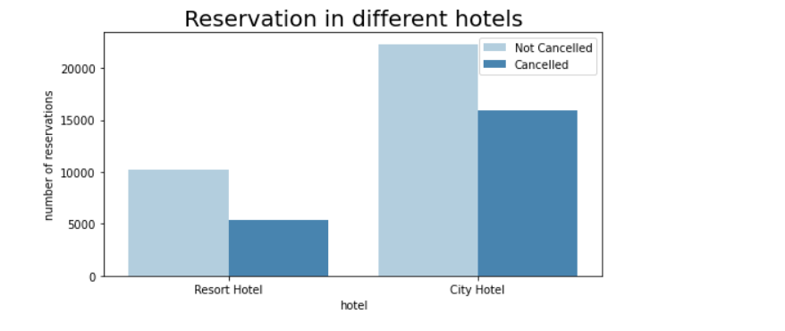

In comparison to resort hotels, city hotels have more bookings. It’s possible that resort hotels are more expensive than that in cities.

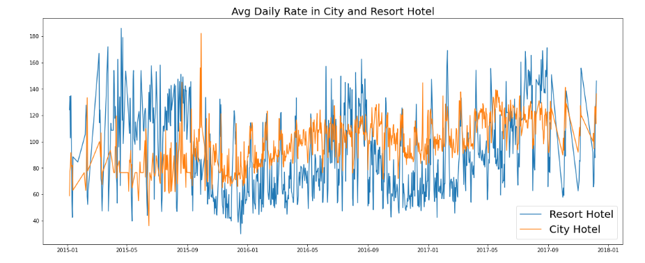

The graph shows that, on certain days, the average daily rate for a city hotel is less than that of a resort hotel, and on other days it is even less. It goes without saying that weekends and holidays may see a rise in resort hotel rates.

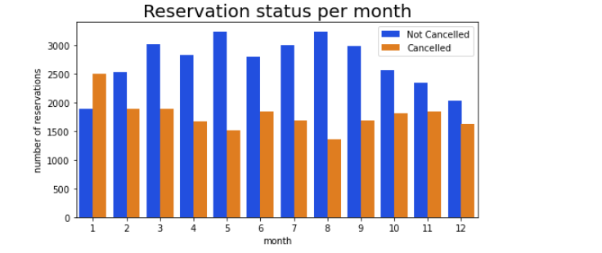

We have developed the grouped bar graph to analyse the months with the highest and lowest reservation levels according to reservation status. As can be seen, both the number of confirmed reservations and the number of cancelled reservations is the largest in the month of August. Where as January is the month with the most cancelled reservations.

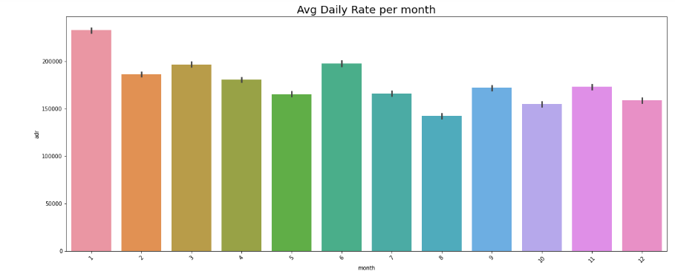

This bar graph demonstrates that cancellations are the most common when prices are greatest and the least common when they are lowest. Therefore, the cost of the accommodation is solely responsible for cancellation.

Now, Let’s see which country has the most cancellation. The top country is Portugal with Highest number of cancellations.

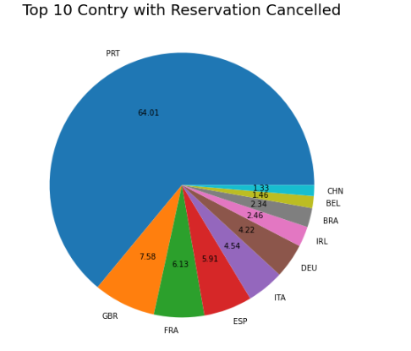

Let’s check the area from where guests are visiting and making reservations.

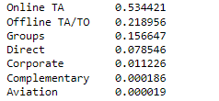

Is it coming from Direct or Groups, Online Offline Travel Agents? Around 53% of the clients come from online and 21% from travel agencies, where as 15% come from groups. Only 4% of the client book hotels directly by visiting them and making reservations.

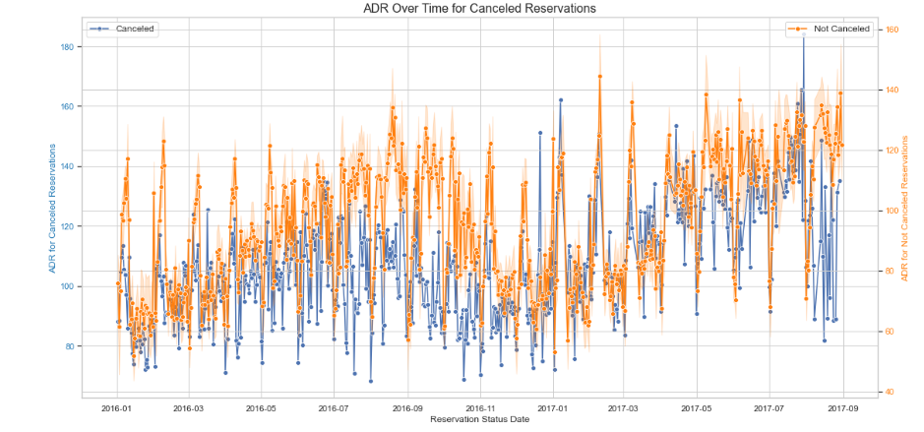

As seen in the graph, reservations are cancelled when the Average daily rate is higher than when it is not cancelled. It clearly proves that all the above analysis, that the higher price leads to higher cancellation.

Suggestions

1. Cancellation rates rise as the price does. In order to prevent cancellations of reservations, hotels could work on their pricing strategies and try to lower the rates for specific hotels based on locations. They can also provide some discounts to the consumers.

2. As the ratio of the cancellation and not cancellation of the resort hotel is higher in the resort hotel than the city hotels. So, the hotels should provide a reasonable discount on the room prices on weekends or on holidays.

3. In the month of January, hotels can start campaigns or marketing with a reasonable amount to increase their revenue as the cancellation is the highest in this month.

4. They can also increase the quality of their hotels and their services mainly in Portugal to reduce the cancellation rate.